Move Production DB to QA Env
- Create a image in production account.
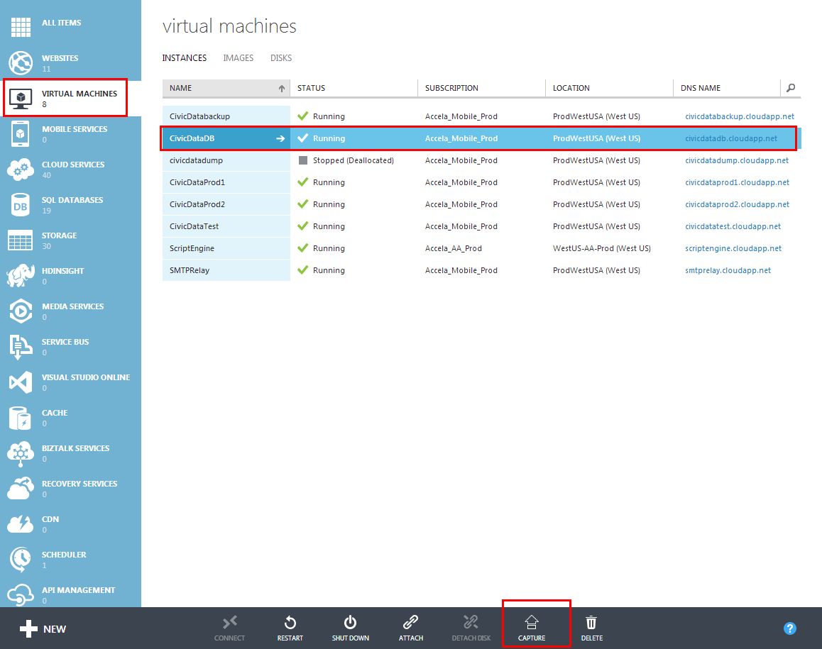

- Turn to detail page of the image which created in step 1 and then you will find the image location url in the follow page:
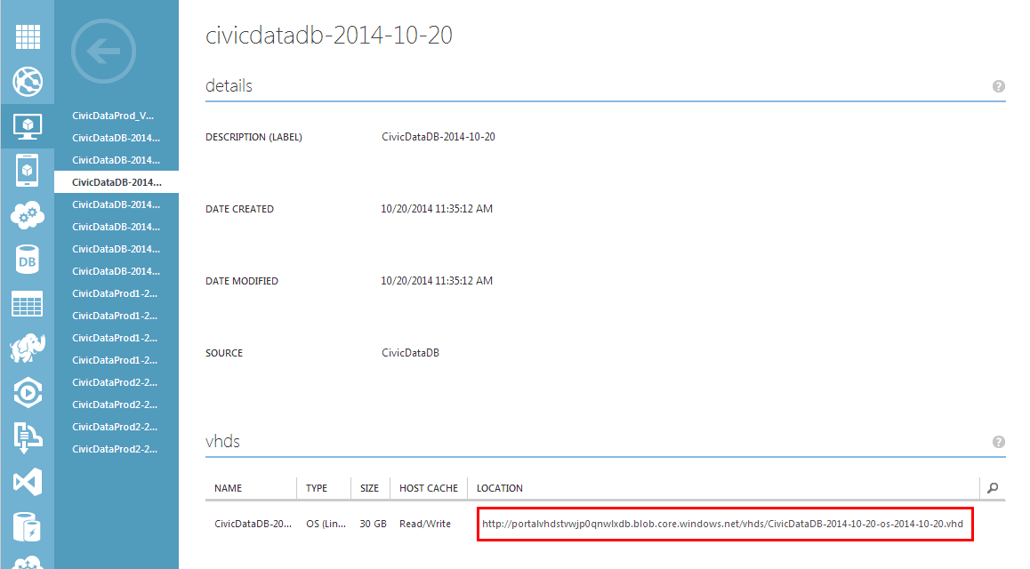

- Turn to Storage page,chose the container item of the image,click “MANAGE ACCESS KEYS”,copy “PRIMARY ACCESS KEY” or “SECONDARY ACCESS KEY”.
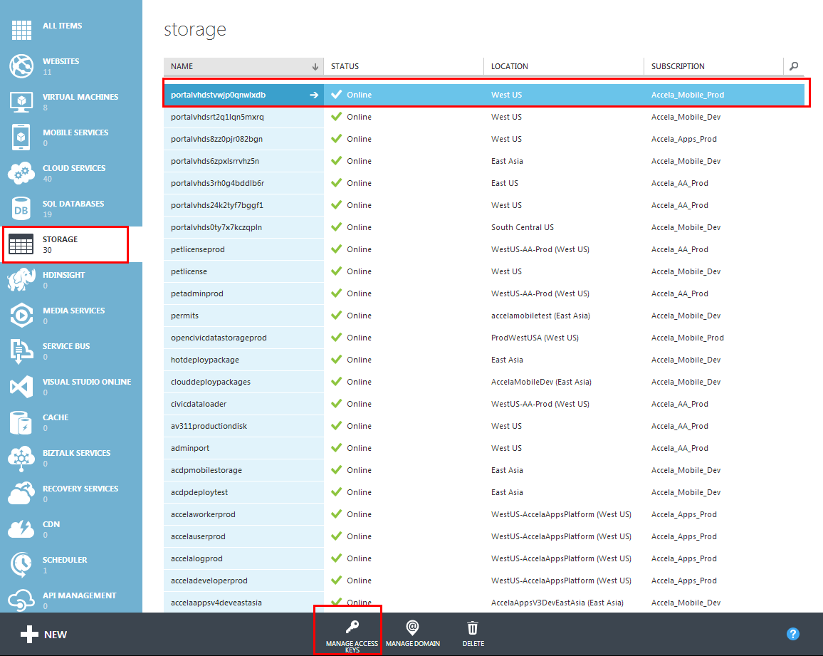
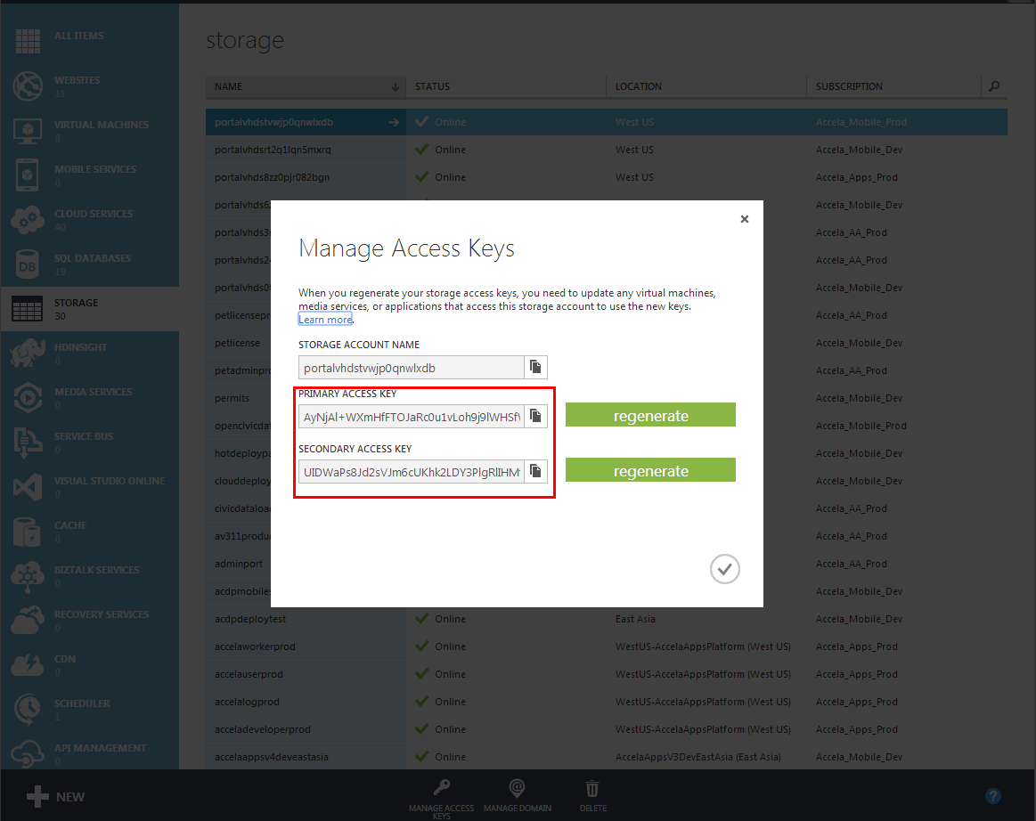
4. Login QA account,and find the destination resource and copy it’s “PRIMARY ACCESS KEY” or “SECONDARY ACCESS KEY”.

5. Download and install AzCopy in windows;If desired, you can add the AzCopy installation location to your system path.
PS:If you want to lean more about AzCopy tools,this url will help you:
http://azure.microsoft.com/en-us/documentation/articles/storage-use-azcopy/

6. Run cmd.exe in windows and execute the command:
AzCopy http://portalvhdstvwjp0qnwlxdb.blob.core.windows.net/vhds/ /sourcekey:AyNjAl+WXmHfFTOJaRc0u1vLoh9j9lWHSfWGIBXUbRuSCB1v9hrb2v1+EKU41CLjGQczn4/cx8oqxFJYqrpW1Q== /destkey:H5psuQpcMZ8IZ9ehEGEFTnl6bldHYf0Shn76d8Fek8cqwdAD+TroIHf83Tfwd9s5ntJxzQoFgomGsZKe6bYjyQ== CivicDataDB-2014-10-20-os-2014-10-20.vhd

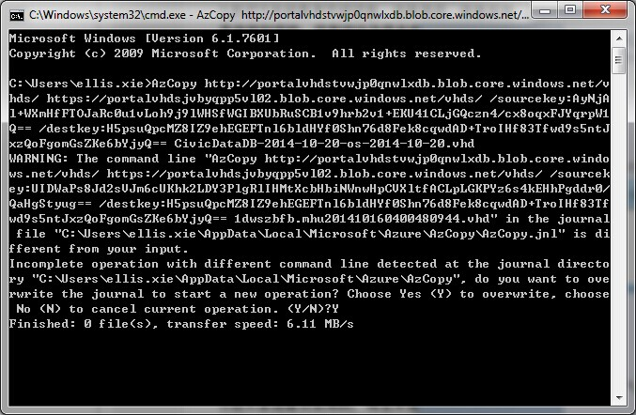
- In QA account,create a image from the vhd file we have copied in step 6, then create a vm from image.

